**Lesson16 Deploy Azure Plan Service from local repository to Azure Portal**

**Notes: -**

**1-on the Azure PowerShell run the following commands**

**$linuxGroup = "DefaultResourceGroup-WEU"**

**$location="West Europe"**

**$webappname="demoApp-1993"**

**//it will create resource group called Linx-Group under location West Europe**

**az group create --name $linuxGroup --location $location**

**//it will create app service plan under resource group with type of B1 of Linux O.S**

**az appservice plan create --name $webappname --resource-group $linuxGroup --sku B1 --is-linux**

**//we deploy azure web app with detect the runtime operation with detect Git-local deployment with enable Deployment local git**

**(we take the web app deployment URL to apply publish .net core project into it)**

**az webapp create --name $webappname --resource-group $linuxGroup --plan $webappname --runtime "DOTNETCORE|3.1" --deployment-local-git**

**in order to face problem in create web app you can create it from azure portal and then enable local git as below**

**Azure 🡪 Deployment Center > Local Git option> Git Automatic Publish**

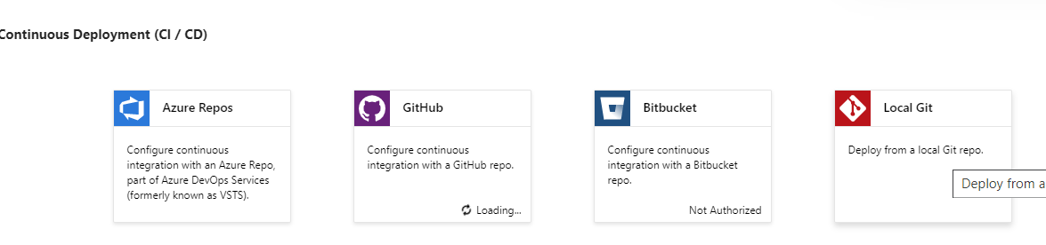

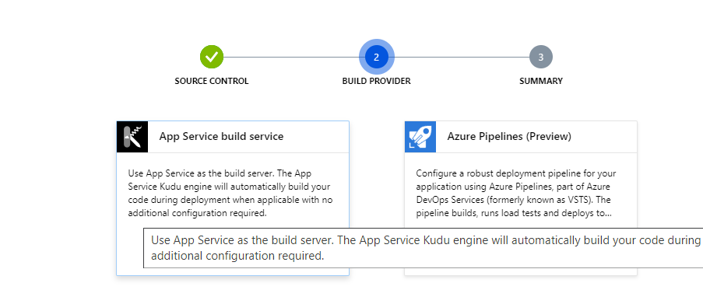

**2-on azure portal we create new azure user to apply deployment from local repository to azure app service with unique username and password**

**az webapp deployment user set --user-name m.enbeh --password Mohammed19993**

**3-on folder execute the following commands to create empty .net core project**

**dotnet --info**

**on the folder path we type the following command to run it as below**

**dotnet new webapp**

**dotnet run**

**4-on Git website you can download and install Git and execute the following code to deploy your code into repository**

**git config --global user.name "m.enbeh"**

**git config --global user.email "mohammedenbah93@gmail.com"**

**git init //(to initialize the git repository)**

**git add . //(to add all the projects in the project folder)**

**git commit -m "first commit" //(to apply commit operation to upload the Git Account)**

**//on git execute the following commands to apply publish operation to Git local repository**

**git remote add azure https://demoapp-1993.scm.azurewebsites.net:443/demoapp-1993.git**

**//we apply publish from local repository to azure app service**

**git push azure master**